**INDIA’S AGRICULTURAL CROPS PRODUCTION ANALYSIS(1997-2021)**

**1.Introduction:**

**1.1 Overview**:

Indian agricultural crop production analysis from 1997 to 2021 reveals significant growth and challenges. During this period, there was an overall increase in food grain production due to advances in technology, irrigation, and government initiatives. However, disparities in crop yields persisted, and the sector faced issues like water scarcity, climate change impacts, and market volatility. Crop diversification and sustainable practices gained importance, highlighting the need for a balanced approach to ensure food security and environmental sustainability.

**1.2 Purpose:**

The Indian agricultural crop production analysis from 1997 to 2021 serves multiple crucial purposes. It enables policymakers to formulate effective agricultural policies, assists farmers in making informed decisions, and aids investors in identifying profitable opportunities. This data can also inform food security strategies, contribute to sustainable agricultural practices, and provide insights into the impact of climate change on crop yields. Furthermore, it supports research and innovation in the agricultural sector, ultimately fostering India's food self-sufficiency and economic growth.

**2.Problem statement & Design thinking:**

**2.1 Empathy Map:**

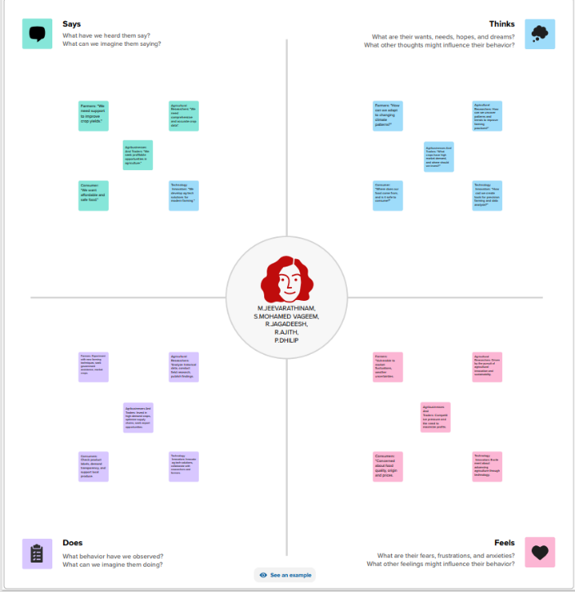

**2.2 Ideation & Brainstorming Map:**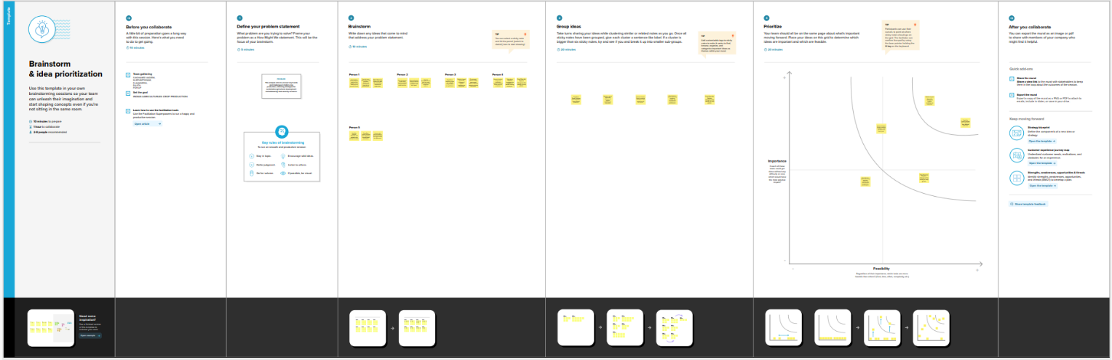

**3.Result:**

**State Wise Agricultural Land:**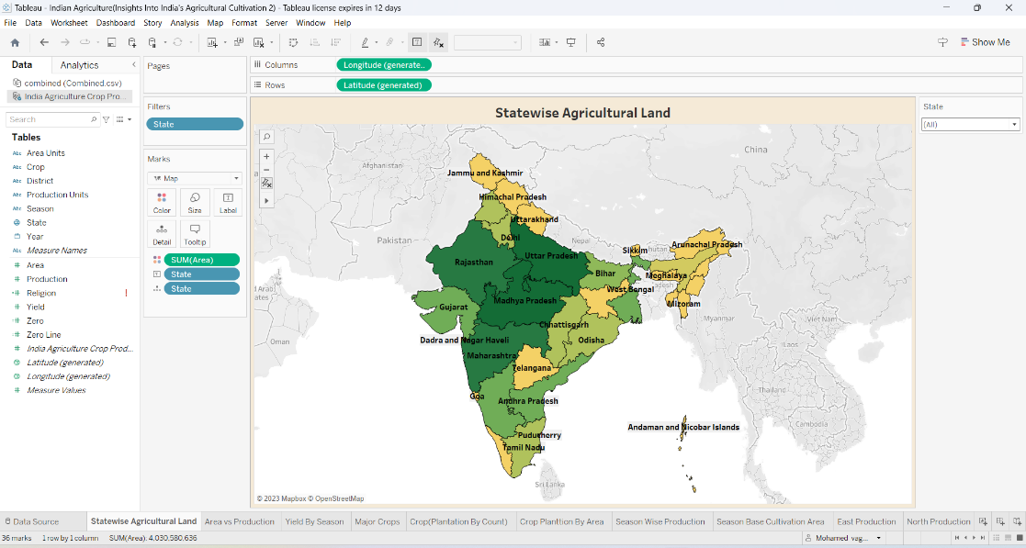

**Area vs Production:**

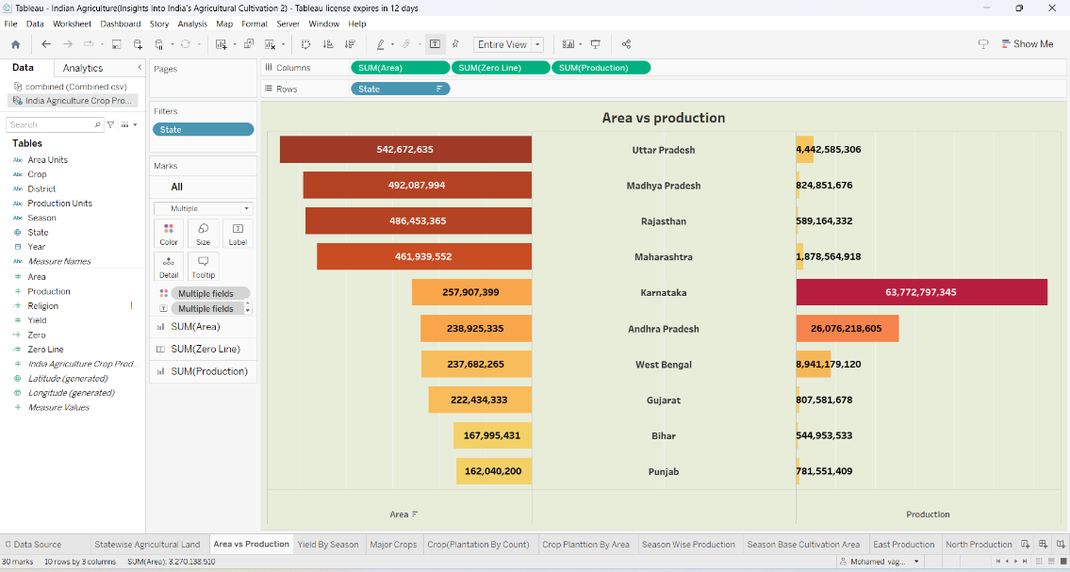

**Crop Plantation By Area:**

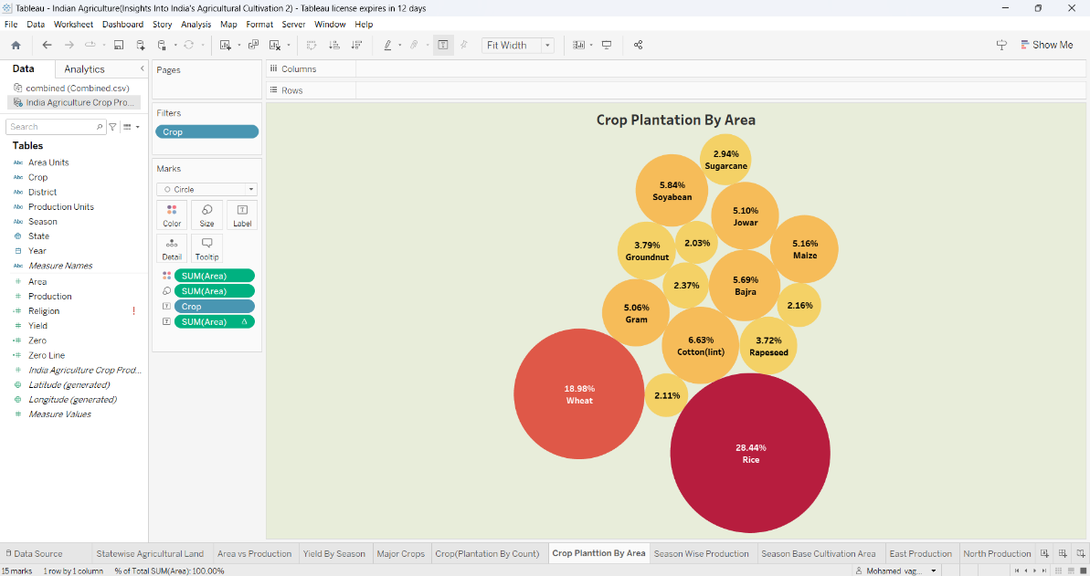

**Crop Plantation By Count:**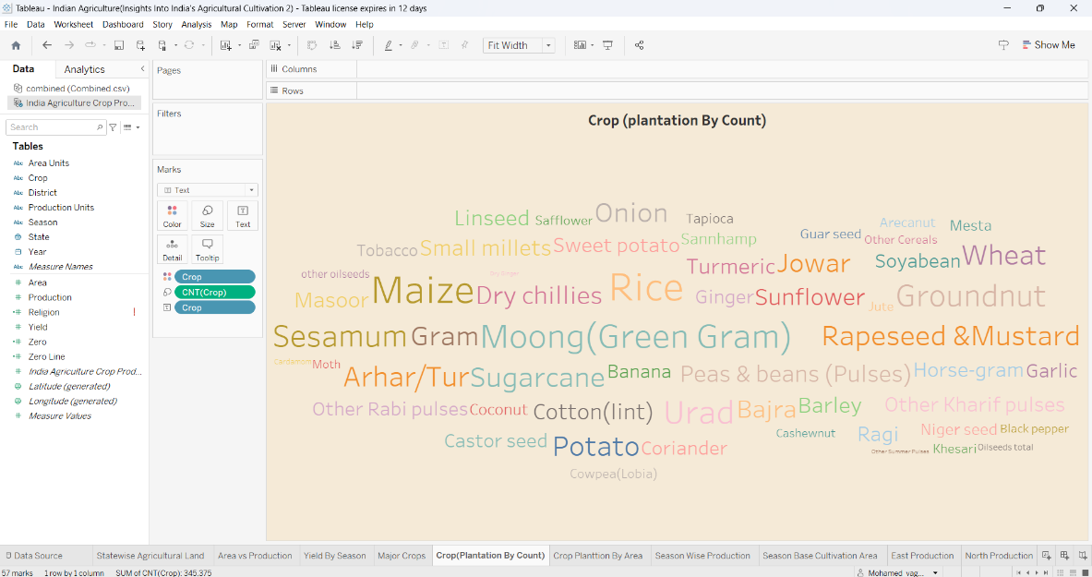

**Major Crop Growth YoY:**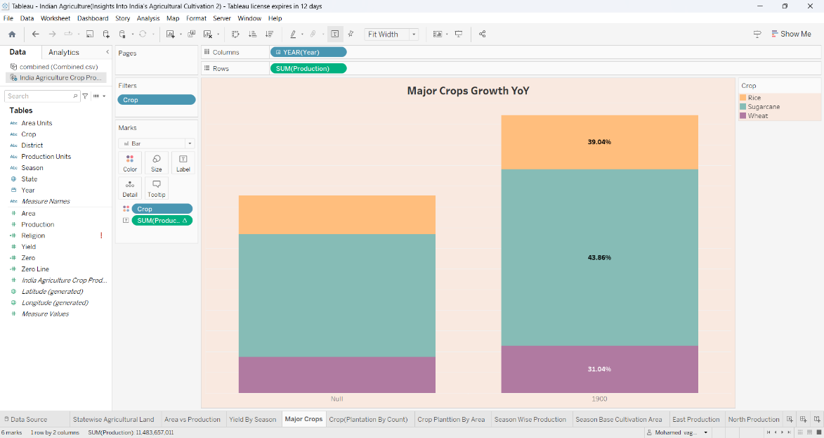

**Season Based Crop Cultivation:**

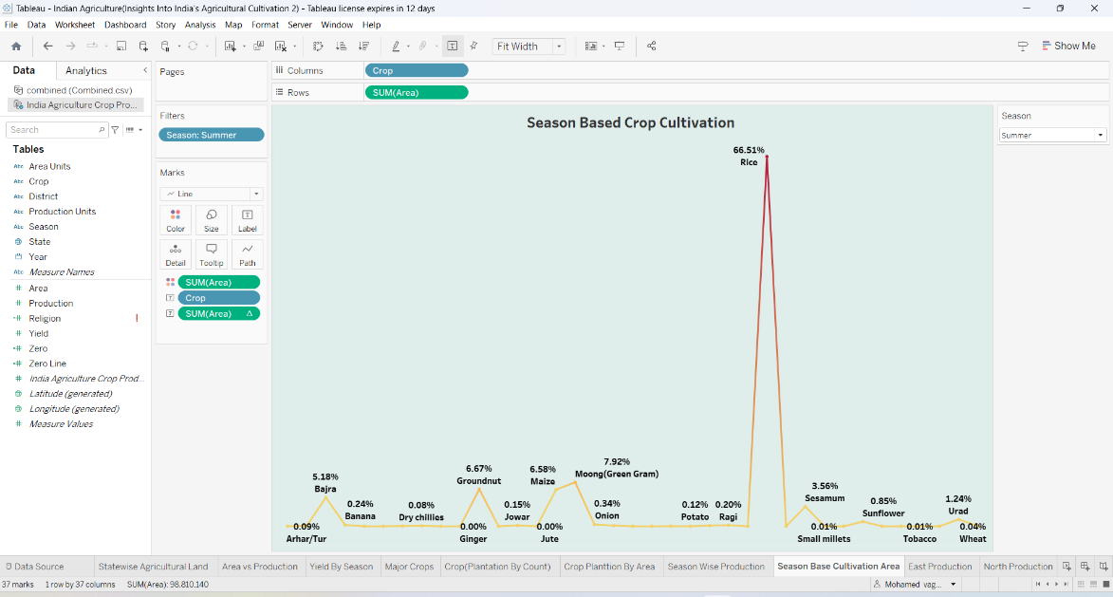

**Season Wise Production:**

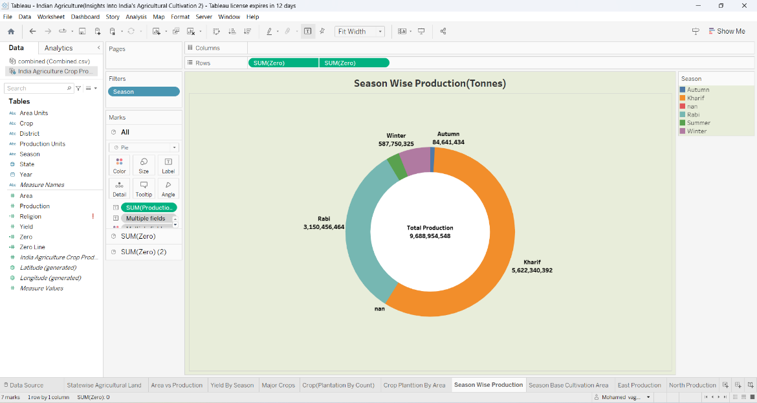

**Yield By Season:**

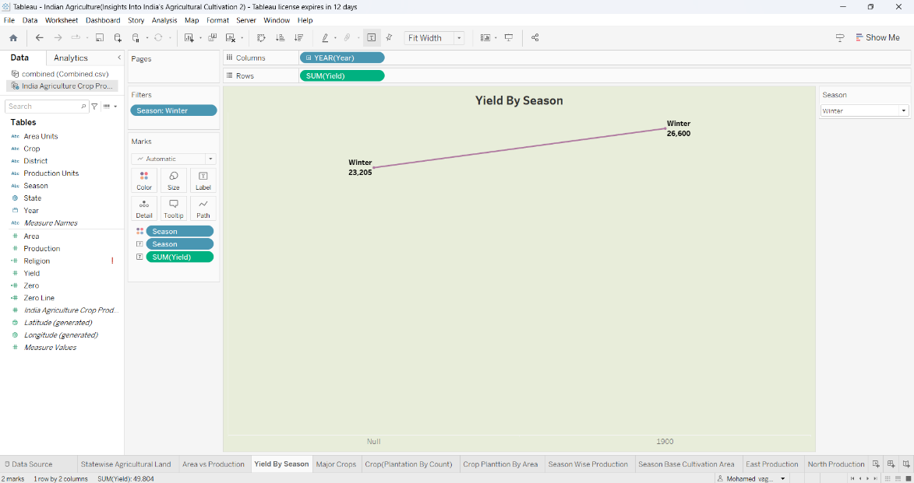

**Dash Board(Area In Acres Region-Wise):**

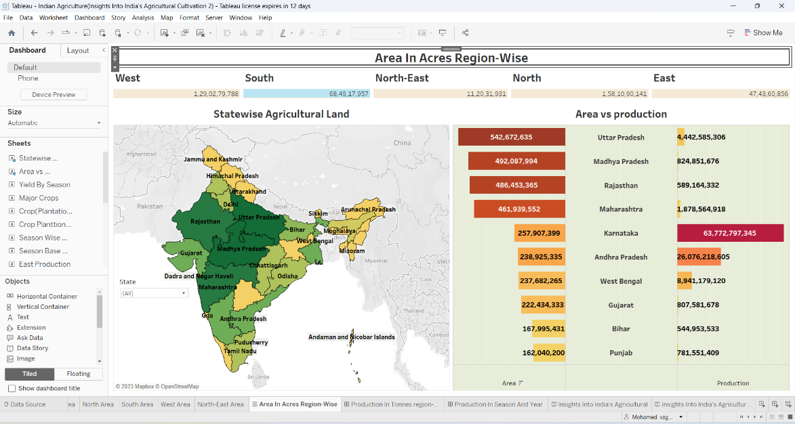

**Production In Tonnes Region-Wise:**

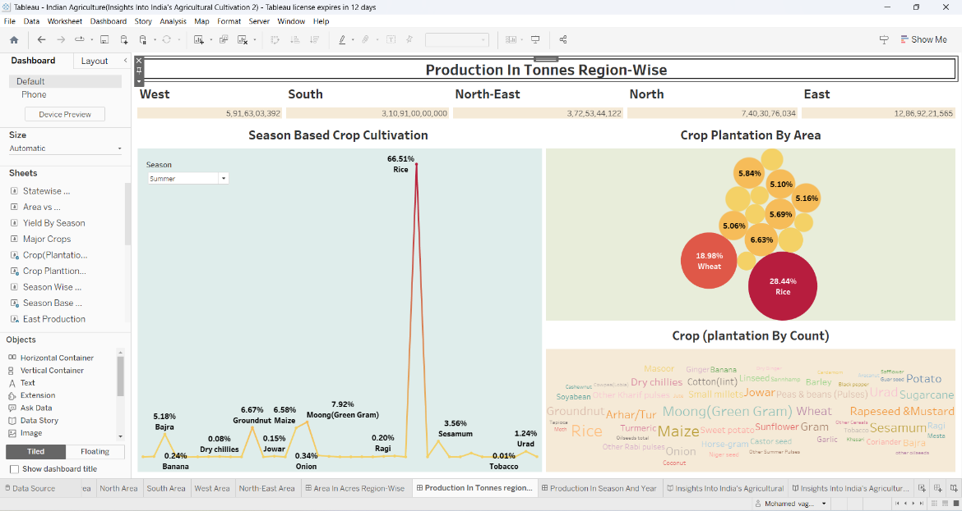

**Production In Season And Year-Wise:**

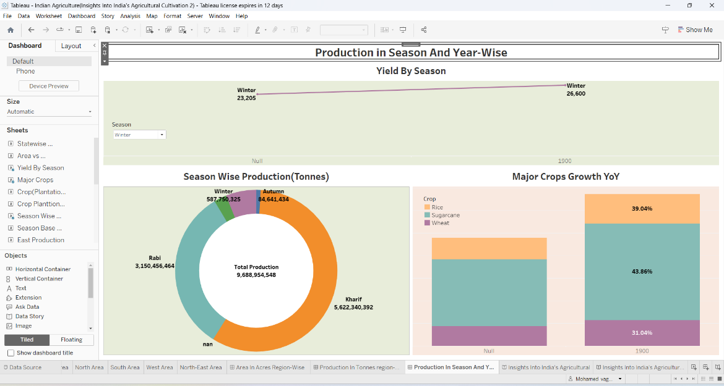

**Story(State wise Agricultural Land):**

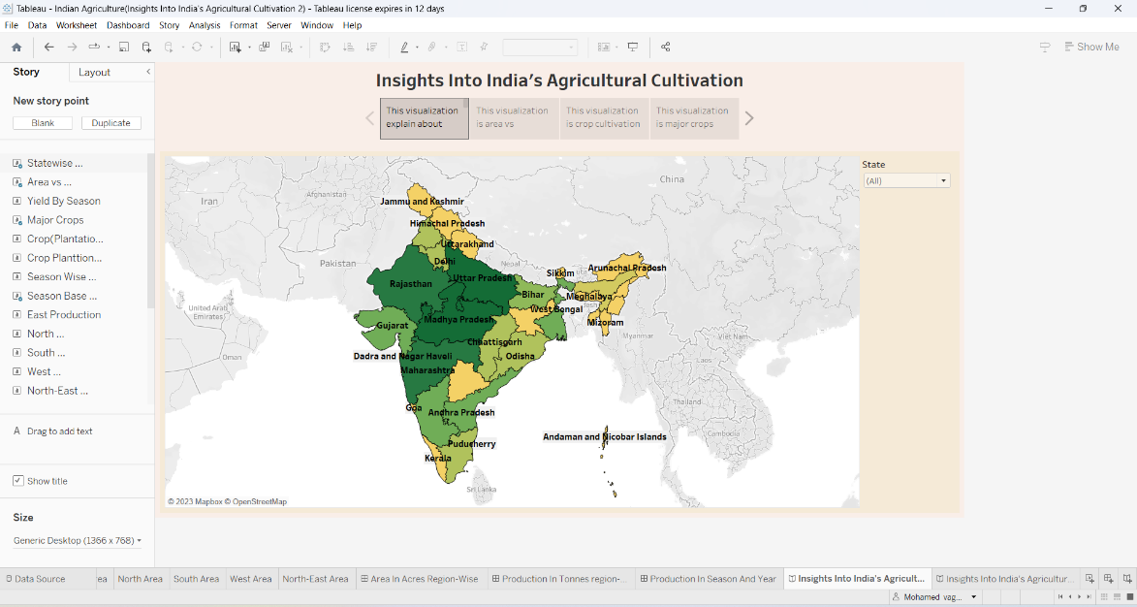

**Story(Area vs Production):**

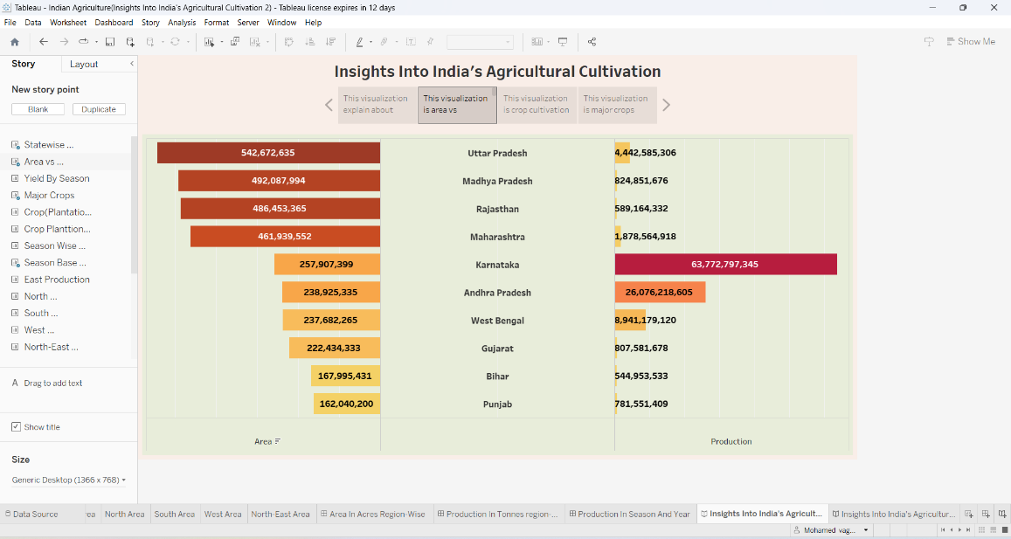

**Story(Season Based Crop Production):**

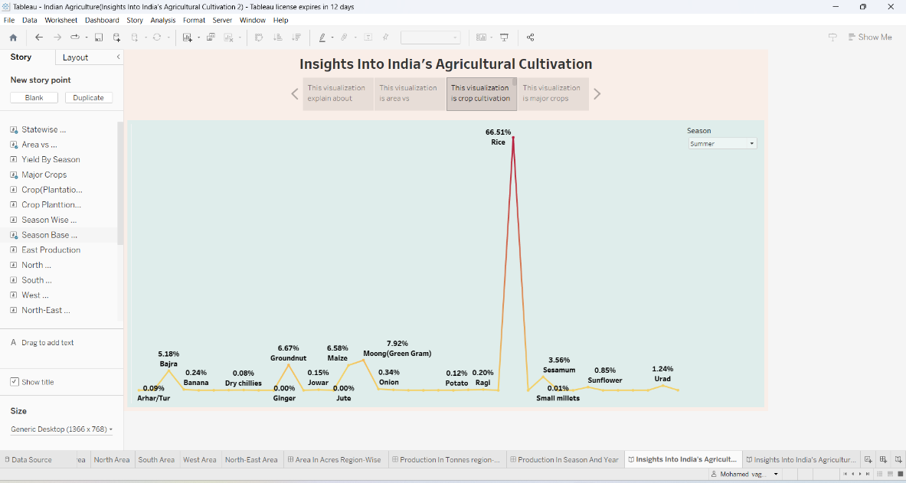

**Story(Major Crop Growth YoY):**

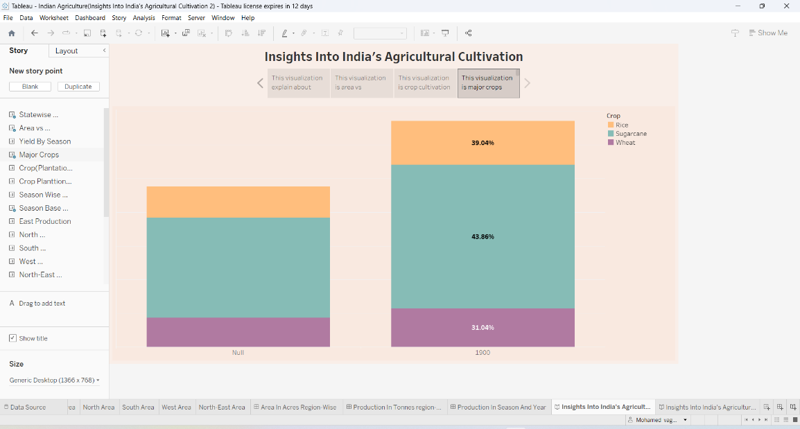

**Story(Crop Plantation By Area):**

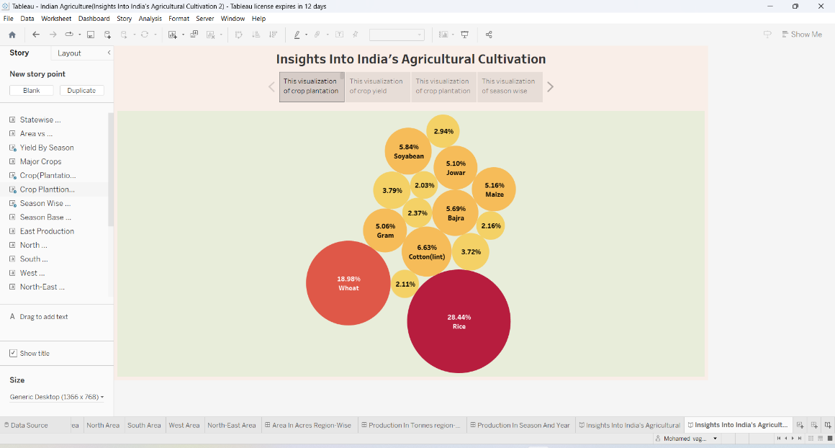

**Story(Yield By Season):**

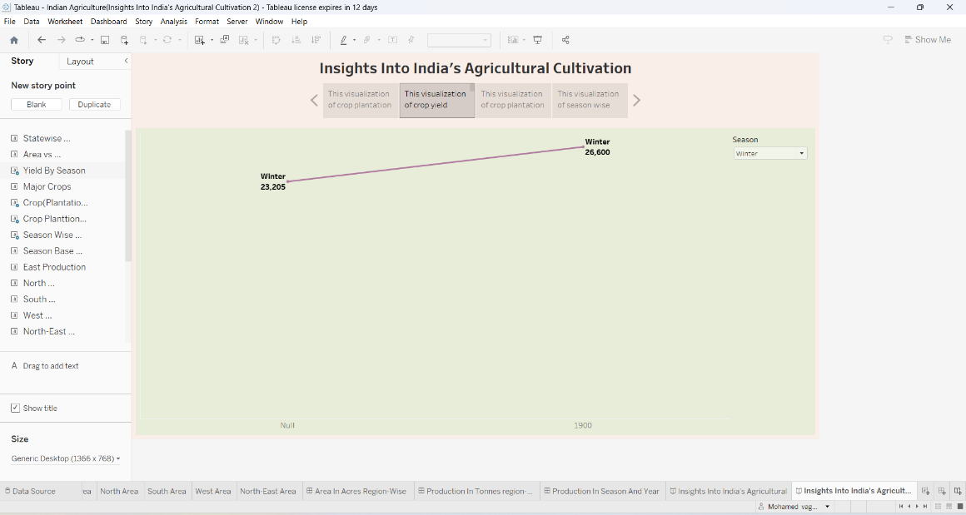

**Story(Crop Plantation By Count):**

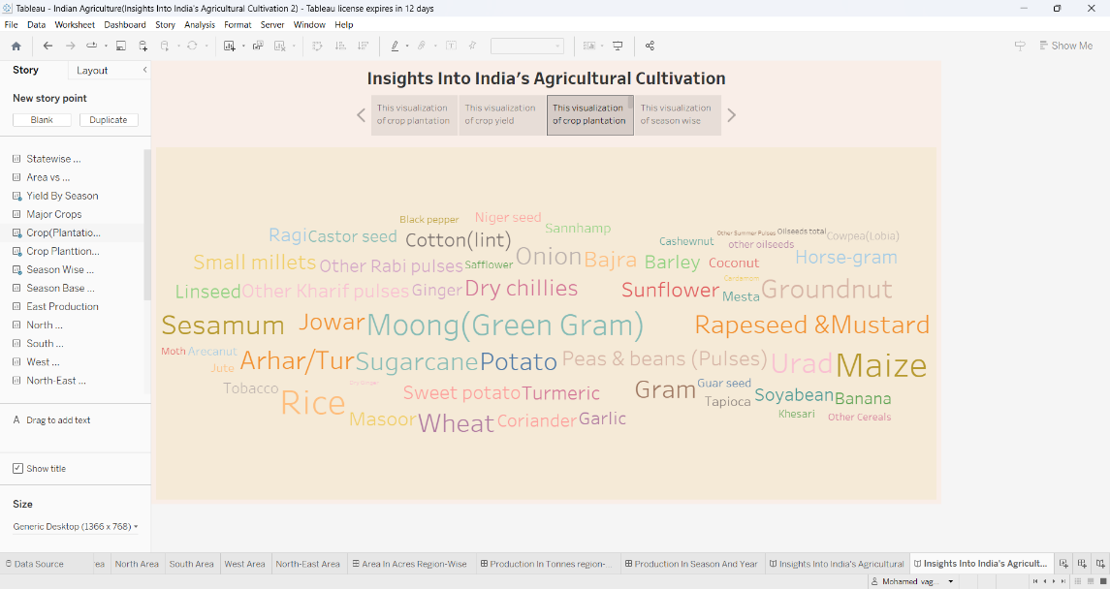

**Story(Season Wise Production):**

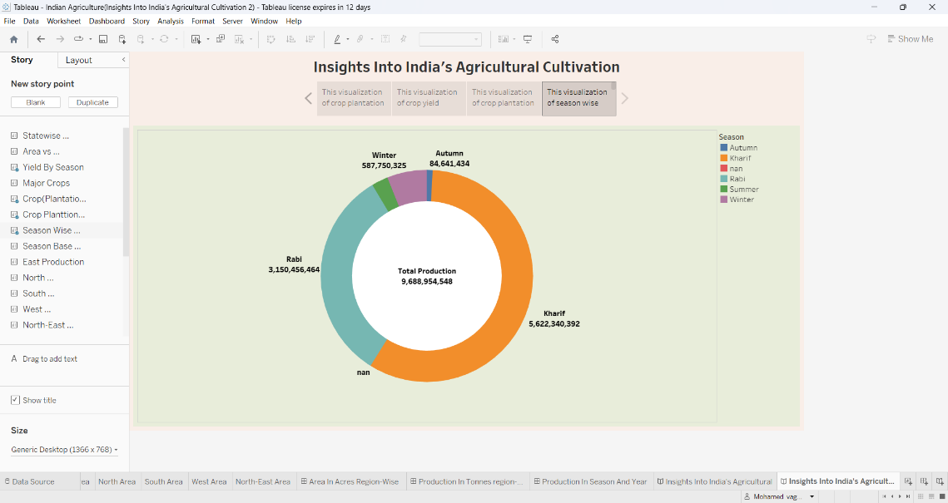

**4.Advantages & Disadvantages:**

**Advantages:**

*The project offers insights into sustainable agricultural practices, helping to reduce environmental impacts and conserve natural resources.

*Analyzing by historical trends, this analysis can help identify factors contributing to increased crop yields, facilitating the implementation of practices that can enhance agricultural productivity**.**

**Disadvantage:**

*Agriculture is influenced by dynamic factors like climate change, which may not be fully represented in historical data, making it challenging to predict future trends accurately.

*Ensuring the accuracy and availability of historical data can be challenging, potentially leading to gaps or inaccuracies in the analysis.

**5.Application:**

*This data has been instrumental in assessing the impact of climate change and weather patterns on crop yields.

*India's agricultural crop production analysis from 1997 to 2021 has been crucial for understanding trends in food production and security.

*Farmers can use this data to make more informed choices about crop selection and planting strategies.

**6.Conclusion:**

The analysis of India's agricultural crop production from 1997 to 2021 reveals significant insights. The sector's growth, the influence of weather patterns, and the impact of technological advancements. This data can guide policies, empower farmers with informed choices, enhance agribusiness efficiency, and inform future research on sustaining India's agricultural resilience and productivity.

**7. Future scope:**

The future scope for India's agricultural crop production analysis (1997-2021) includes leveraging AI and data analytics to predict crop yields, exploring sustainable farming practices, and developing real-time monitoring systems for precise resource allocation.